Creating & Viewing Sub Sites

[Echoes - Land Management](https://echoes-platform.eu/app/main/map-view)

21 Steps

Go to <https://echoes-platform.eu/app/main/sites/my-sites> then choose your site you want to create a Sub Site in.

1 - Viewing all your Sub Sites

To start a new Sub Site;

* Click on the Actions button
* Then click on the 'Create/Edit Subsite' option

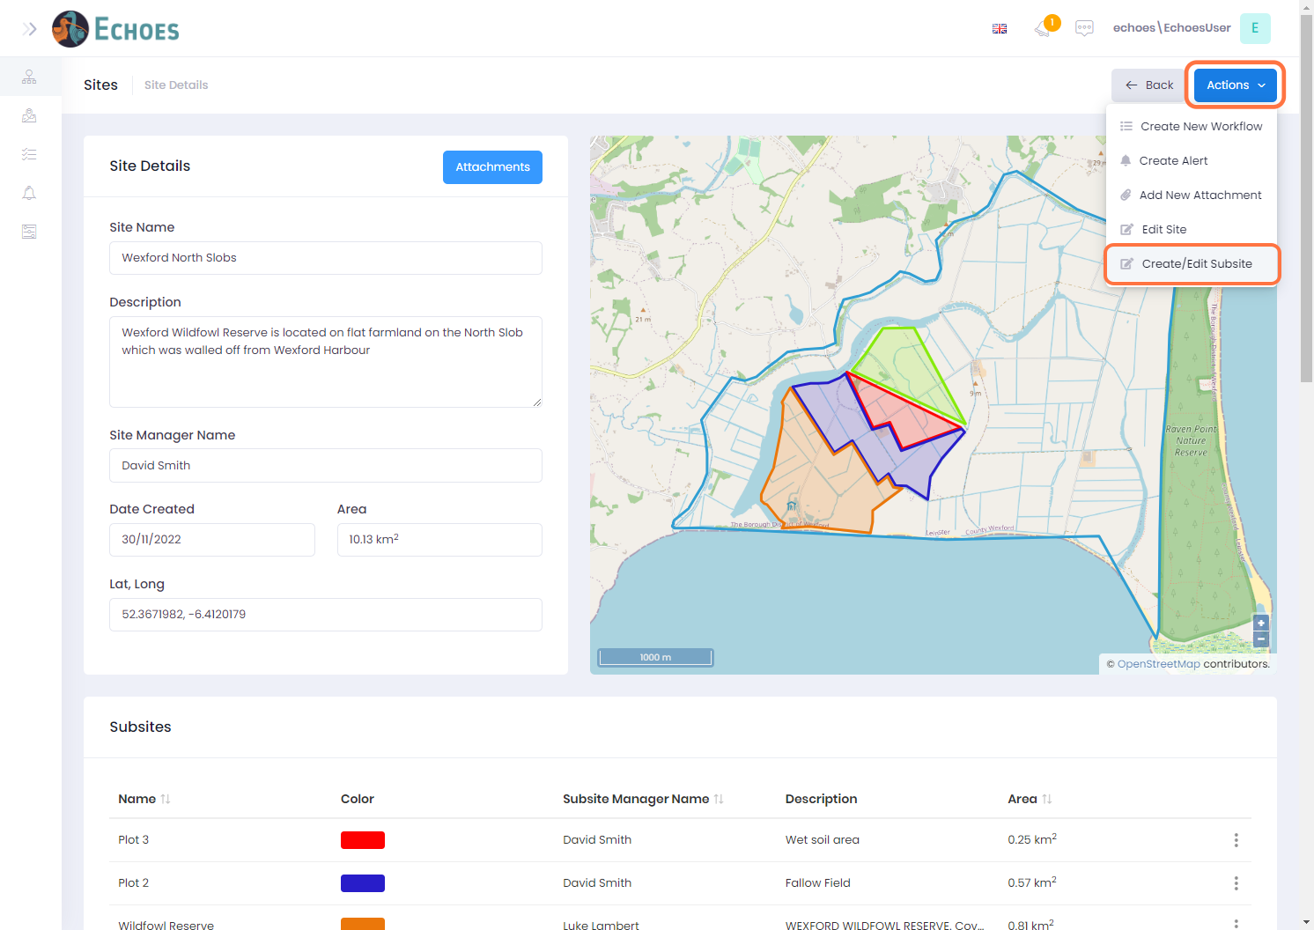

2 - Editing Sub Site information

You will now see a list of all your sub sites associated to your chosen site. Here you can edit any information about all your sites in one place.

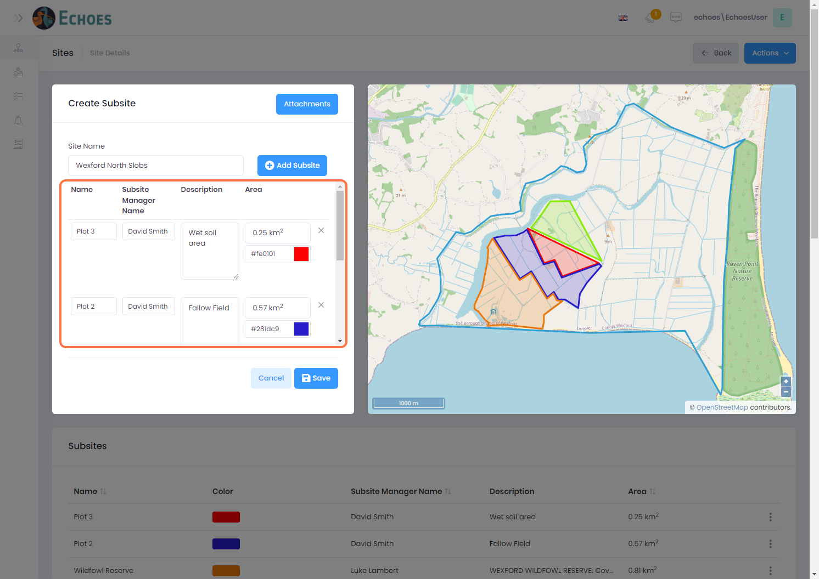

3 - Identifying your Sub Site

Hovering over a row will highlight the corresponding sub site on the map view to the right-hand side.

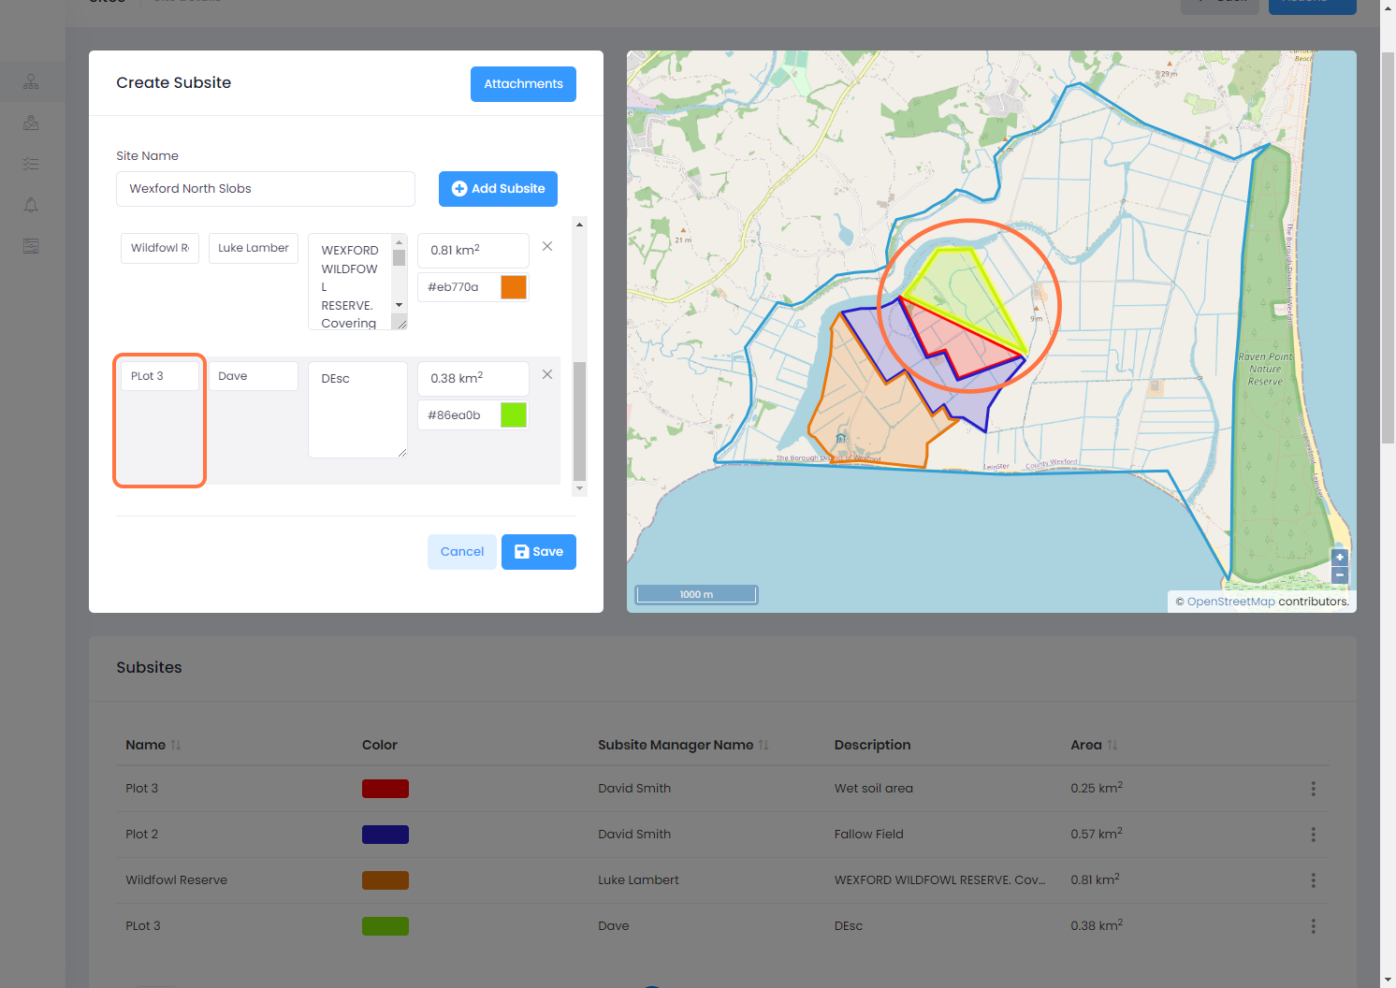

4 - Creating a new Sub Site

The Create a new sub site, click on 'Add Subsite' button to begin.

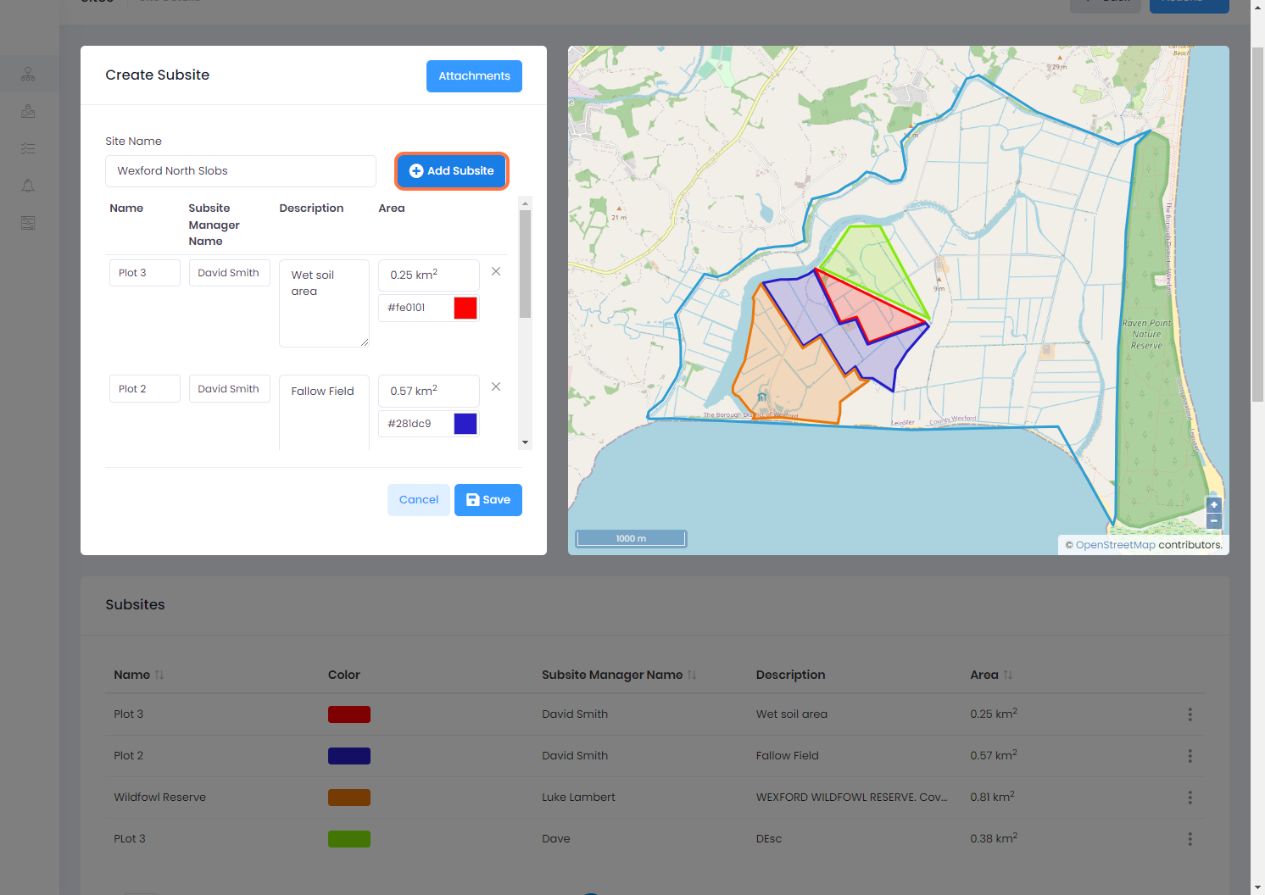

5 - Drawing the boundary of your new Sub Site

You will now have the drawing tool available. Click to start drawing the boundaries of your sub site, clicking on the 1st point to finish, or double clicking.

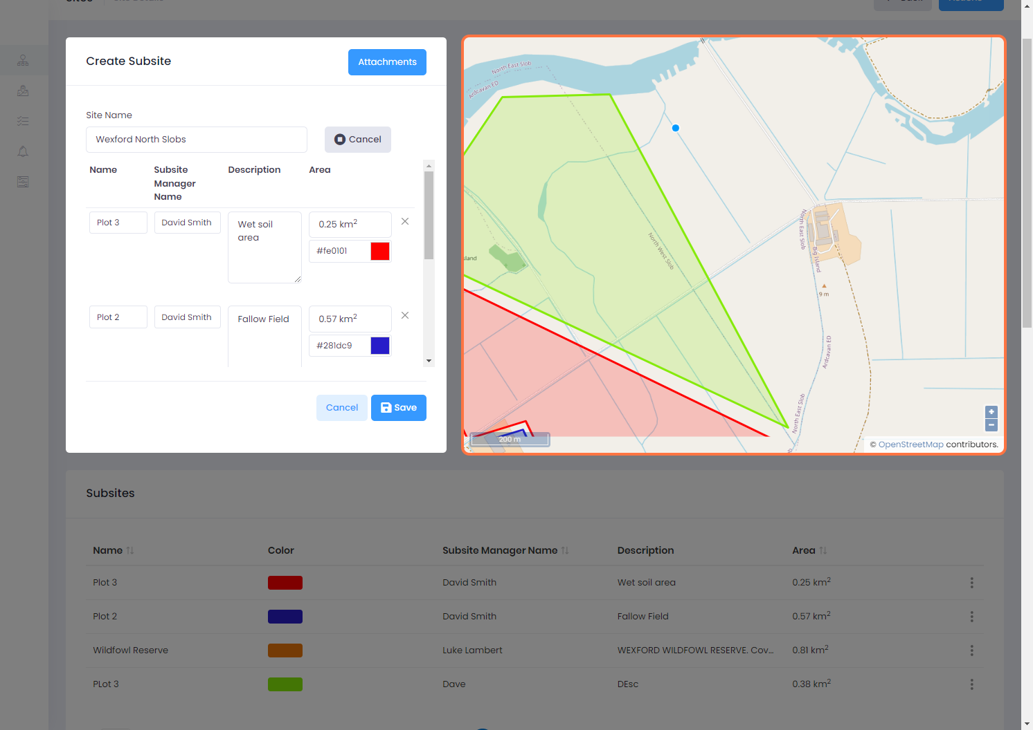

6 - Giving your new Sub Site details

Once you have finished drawing the boundary of your site, you can now give it some details. To do this first type the name of your site, the site managers name and then a description if you have one.

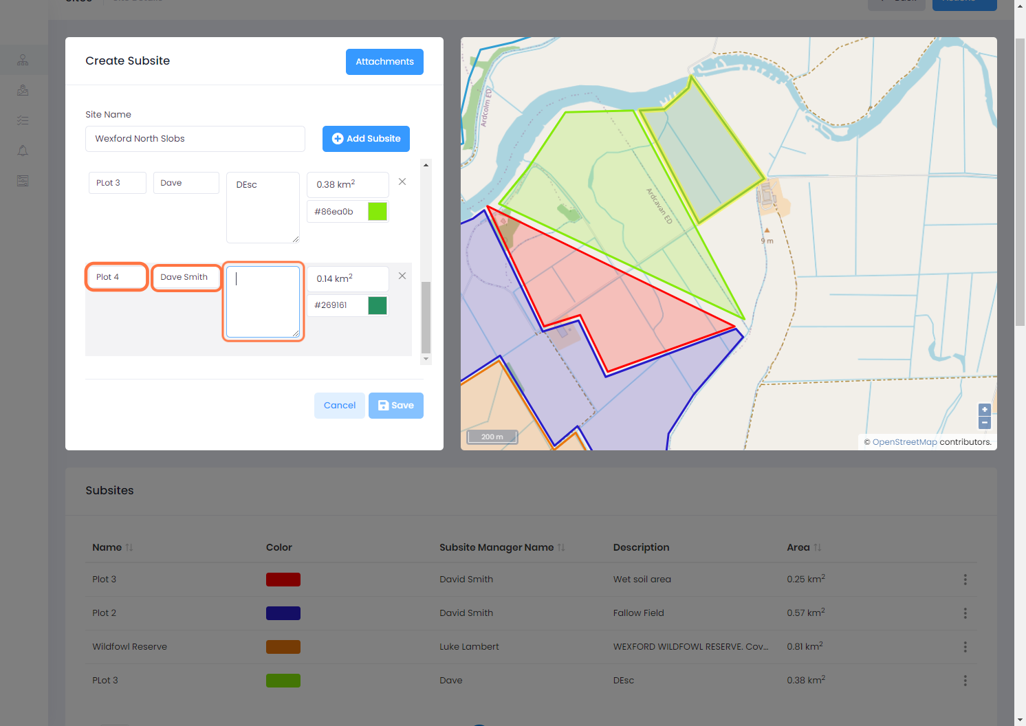

7 - Giving your Sub Site its identifying colour

To set each sub site apart, you can give them individual colour. Click on the colour icon to change the colour of the sub site for the map.

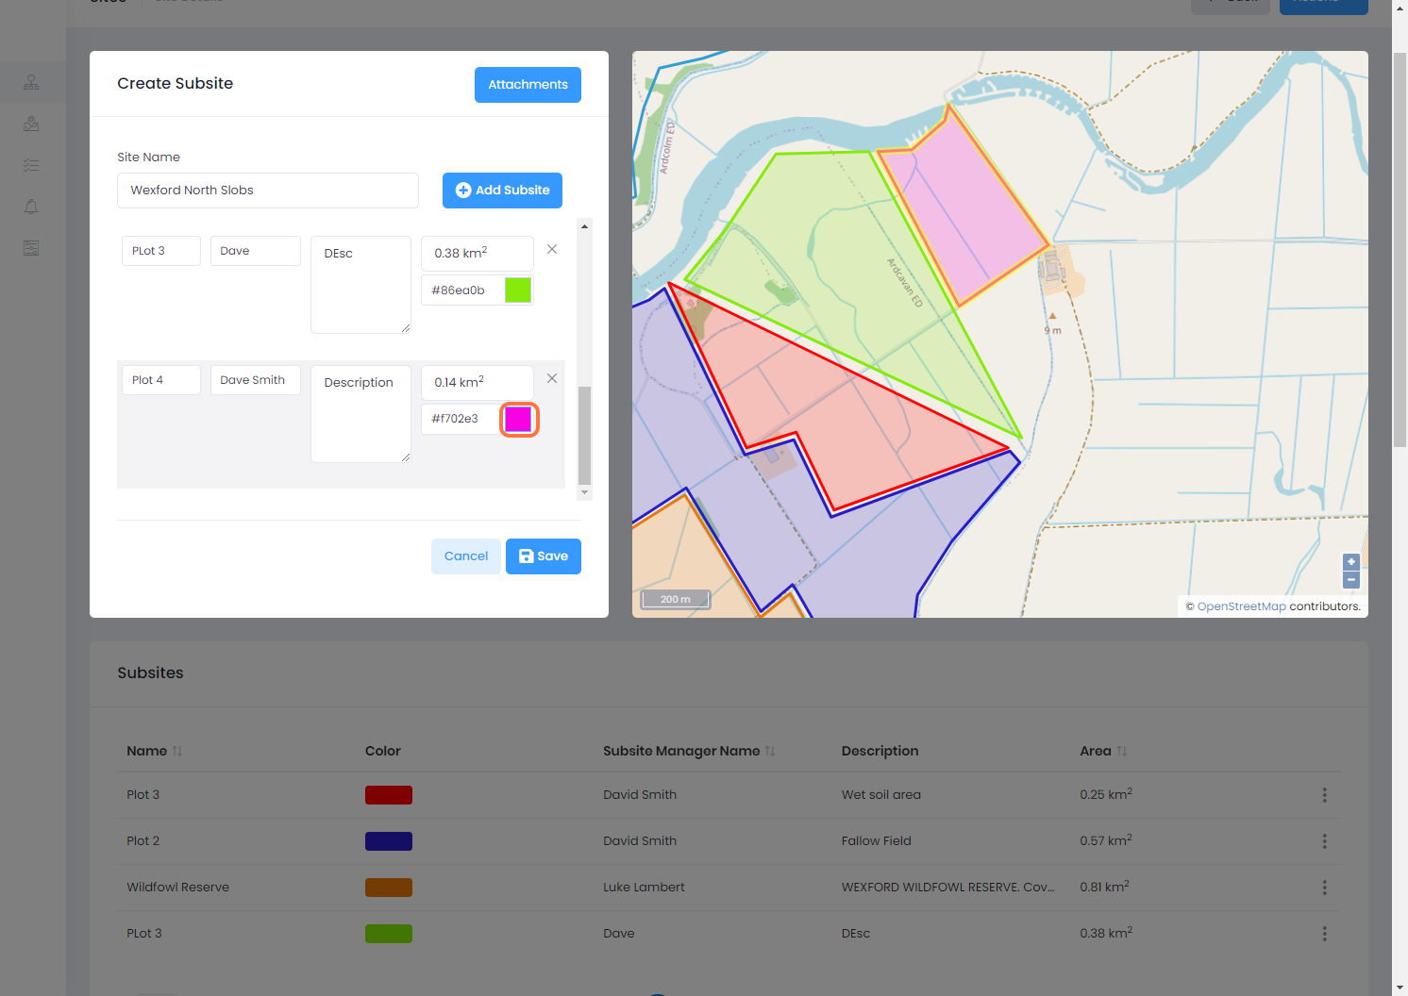

8 - Saving your new Sub Site

Once you have added your new site, or completed any changes, click the 'Save' button.

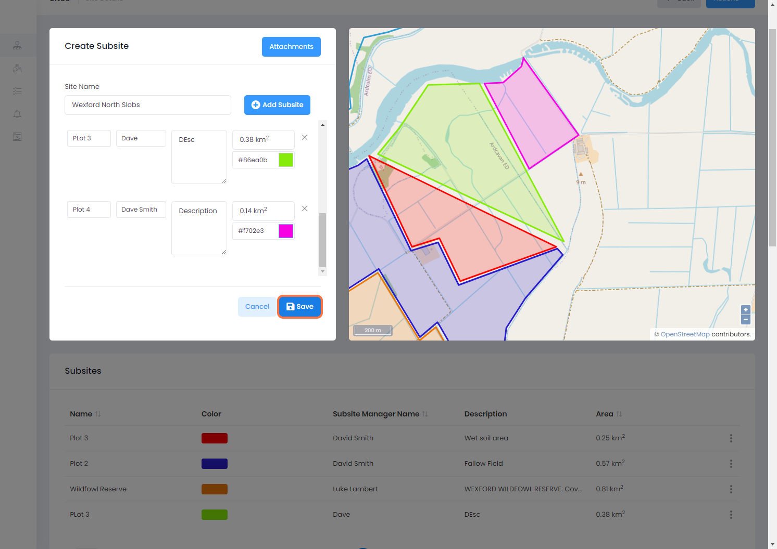

9 - New Sub Site visible

You will now see your new sub site or changes reflected on the sites map.

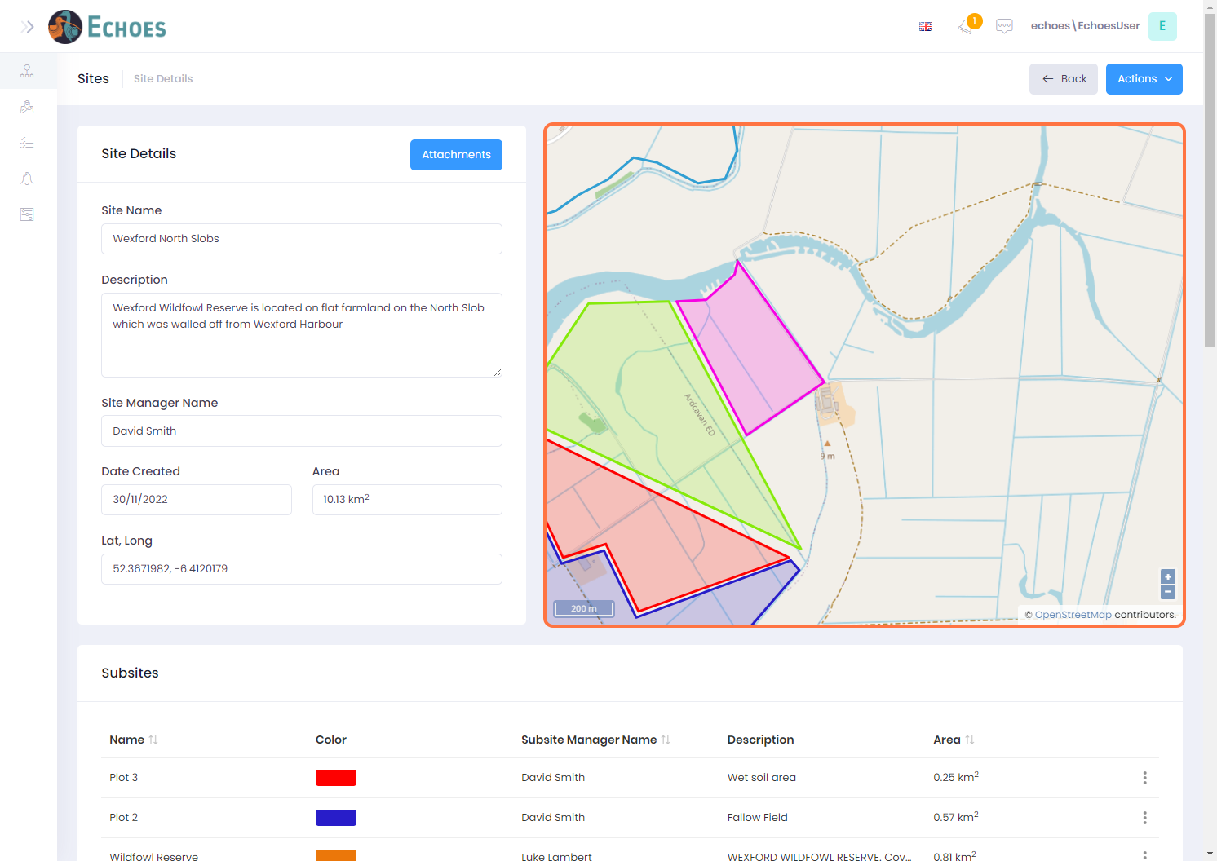

10 - Viewing your Sub Sites details page (1/2)

* By clicking on the map, a popup will appear similar to below, then you can click the 'See Subsite Details' button.

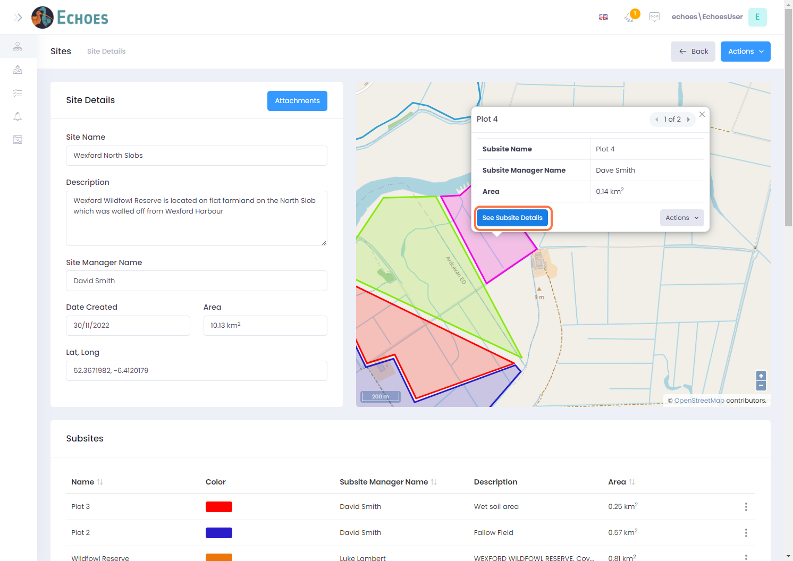

11 - Viewing your Sub Sites details page (2/2)

* From the subsites data table in the Sites details page, click on the ellipses of the subsite you want to view, then click the 'Details' option.

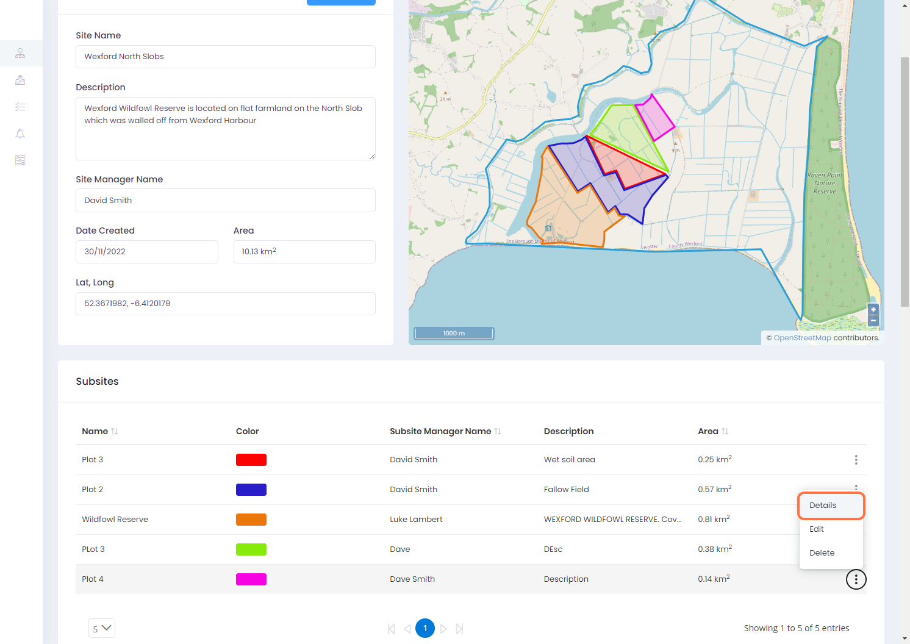

12 - Sub Sites details page

You will now see a view similar to the site details page, only this page is for the Subsite you chose. Workflows, Alerts & Attachments for this sub site only will be visible here.

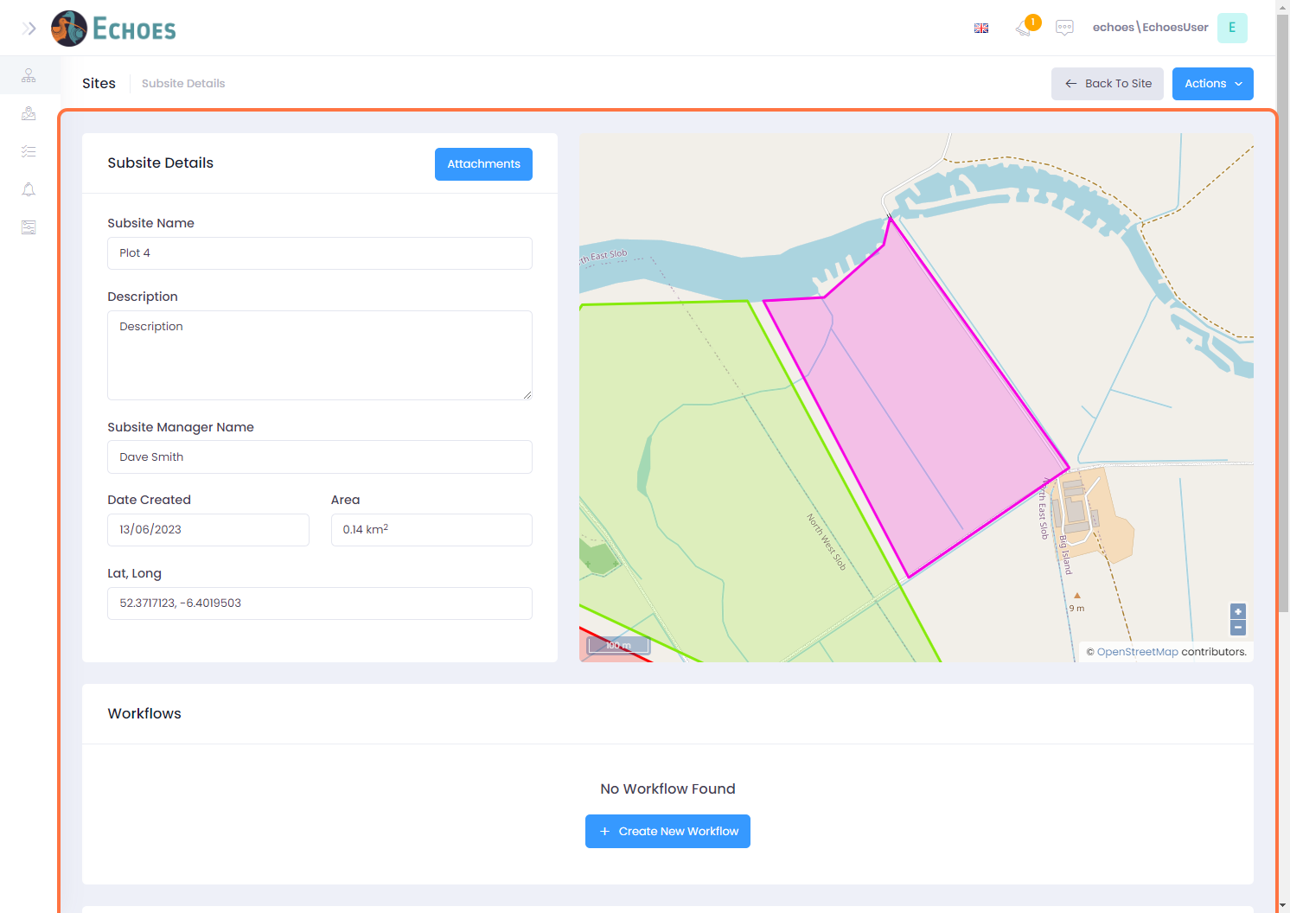

13 - Actions you can take on your Sub sites.

Here you can perform all the same actions as you can in the Site details page apart from the creation of a sub site within a sub site.

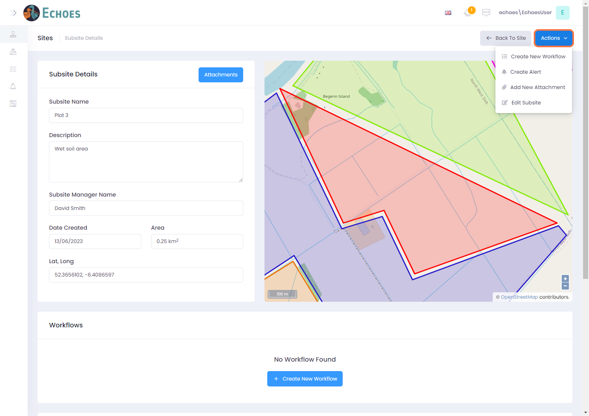

14 - Going back to your Site Details page

You can go back to your sites details by clicking the 'Back to Site' button.

